Bangladesh Medical Association (BMA)
List of Life Member-14
33. BMA Lalmonirhat Branch

Sl No | Voter No | Voter Details
1 | Voter No  LM-3300001  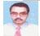 | DR. BHOLA NATH BHATTACHERJEE  F/Name: Satyendra Kishor Bhattacherjee  M/Name:  BM & DC Reg. No:  NID:  Cell:  Address: Railway Hospital  Lalmonirhat  Blood Group:
2 | Voter No  LM-3300002  No Image | DR. MD. TOWHEED HOSSAIN  F/Name:  M/Name:  BM & DC Reg. No:  NID:  Cell:  Address: Upasham, Poura Market  Sadar Thana  Lalmonirhat.  Blood Group:
3 | Voter No  LM-3300003  No Image | DR. MD. ABDUL HAKIM  F/Name:  M/Name:  BM & DC Reg. No:  NID:  Cell:  Address: TRANSFERED to BMA Rangpur Br.  LM-131.  Blood Group:  TRANSFERED to BMA Dhaka City  LM-1405543
4 | Voter No  LM-3300004  No Image | DR. MD. ABDUR RAZZAQUE  F/Name:  M/Name:  BM & DC Reg. No:  NID:  Cell:  Address: Medical Officer (MCHFP)  M&CWC., Lalmonirhat.  Blood Group:
5 | Voter No  LM-3300006  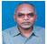 | DR. MD. ZAKIUL ISLAM FARUQUE  F/Name: Md. Omar Ali  M/Name:  BM & DC Reg. No:  NID:  Cell:  Address: Doyel Clinic  Jail Road, Lalmonirhat  Blood Group:
6 | Voter No  LM-3300007  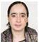 | DR. SALINA RAHMAN  F/Name: Mizanur Rahman  M/Name:  BM & DC Reg. No:  NID:  Cell:  Address: Doyel Clinic  Jail Road,Lalmonirhat.  Blood Group:
7 | Voter No  LM-3300008  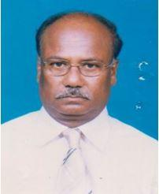 | DR. MD. ABDUS SOBHAN  F/Name: Late. Jamiruddin Ahmed  M/Name: Most. Shefatun Nessa  BM & DC Reg. No: 7450  NID: 4911840080704  Cell: 01716696223  Address: Civil Surgaon, Lalmonirhat  Blood Group: A+
8 | Voter No  LM-3300009  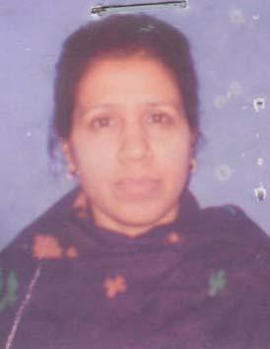 | DR. MAHMUDA BEGUM  F/Name: Late Abul Monsur  M/Name: Fatema Begum  BM & DC Reg. No: 18118  NID: 24906079151  Cell: 01712265715  Address: Sador, Hospital Lalmonirhat  Blood Group: B+
9 | Voter No  LM-3300010  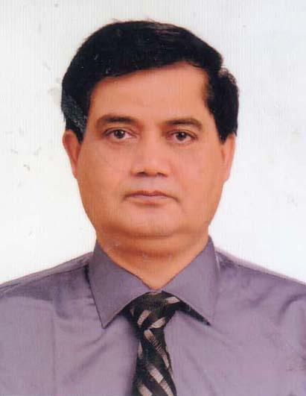 | DR. MD. JAHANGIR ALAM SARKER  F/Name: Late. Dr. Asgar Ali Sarker  M/Name: Mrs. Jobeda Begum  BM & DC Reg. No: 12794  NID: 5225501100058  Cell: 01712000489  Address: Lalmonirhat  Blood Group: B+
10 | Voter No  LM-3300011  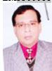 | DR. ABUL FATTAH AHSAN ALI  F/Name: Asraf Ali  M/Name: Hasina Khatun  BM & DC Reg. No: A17476  NID: 5225506131448  Cell:  Address: Sadar Hospital, Lalmonirhat.  Blood Group: A+
11 | Voter No  LM-3300012  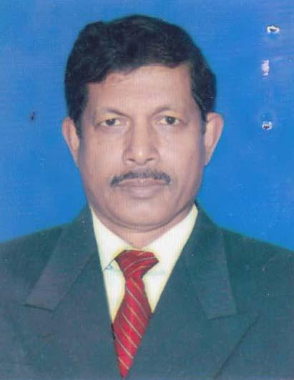 | DR. MD. KASHEM ALI  F/Name: Late. Jafor Uddin  M/Name: Late. Amiron Nesa  BM & DC Reg. No: 15159  NID: 5225508136171  Cell: 01712438869  Address: Upazilla Health Complex, Aditmari, Lalmonirhat  Blood Group: AB+
12 | Voter No  LM-3300013  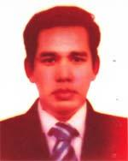 | DR. MORSHED GONI  F/Name: Md. Azizul Haque  M/Name: Mst. Morsheda Begum  BM & DC Reg. No: 34071  NID: 19772716469299280  Cell: 01816673656  Address: Junior Consultant, Upazilla Health Comples, Kazigonj, Lalmonirhat  Blood Group: A+
13 | Voter No  LM-3300014 | DR. RAFIQUL ISLAM  F/Name: Mir Kashem  M/Name: Rubi Begum  BM & DC Reg. No: 56205  NID: 8524901005995  Cell: 01738341882  Address: Lalmonirhat.  Blood Group: AB+
14 | Voter No  LM-3300015  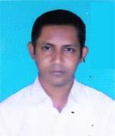 | DR. JILLUR RAHMAN SIDDIKI  F/Name: Md. Nazrul Islam  M/Name: Most. Josna Begum  BM & DC Reg. No: 54519  NID: 8524904043147  Cell: 01712663892  Address: Kaligonj, Lalmonirhat  Blood Group: A+

